EGG RACE

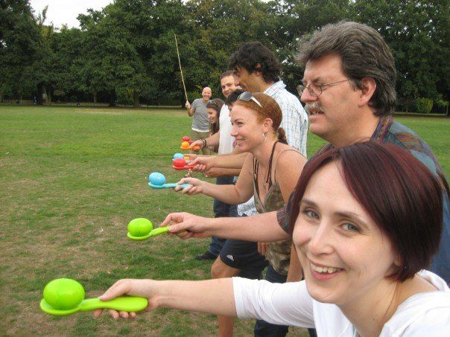

INSTRUCTIONS:

Each of you will take turns racing with a wooden egg on your spoon down to the cone and back while trying not to drop your egg.

If you do you must go back and start over. HOWEVER, after the 3rd try…just pick up your egg where it fell, put it on the spoon and keep on going from there.

Shout out encouraging words to each other.

Parents, you can even walk beside your child to encourage them if they want you too.

Maybe an adult from the group should go first to see how hard it is and to show the rest of your kids how to do it. And tell them the secrets to success. I’ll give you just a minute to get lined up in the order you want to go in.

Then wait till I say go.

HOT POTATO - BALL TOSS

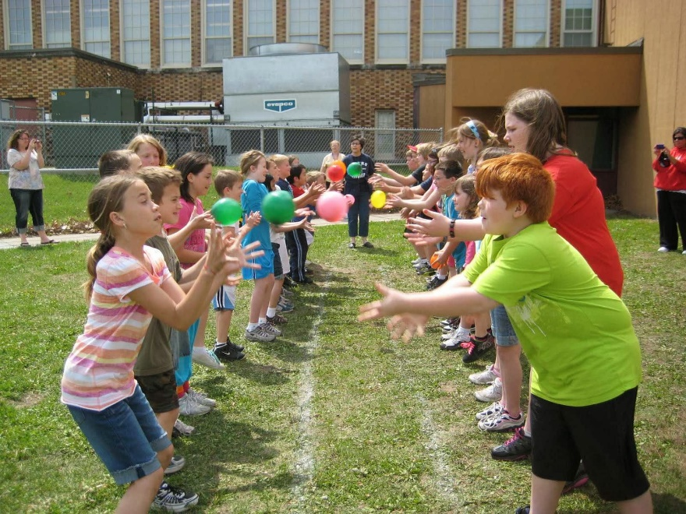

INSTRUCTIONS:

In this relay you will pair off in groups of two.

You will start off facing each other.

When I say go you will toss the ball to the next person.

If you catch it without dropping it, you both take one step back.

Then I will say “toss” again. You toss it back to the other person, etc.

GUNNY SACK RACE

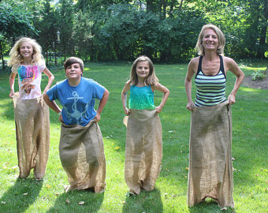

INSTRUCTIONS:
(In this relay race we encourage you to race as a team or family.)

In this relay you are going to jump for joy too. You will take turns jumping for joy.

This is the way it will work. The first person will jump for joy to the cone and come back. Then the second person will start.

When everyone has completed the course, you’re done.

Parents, you may have to help your little ones with their sacks and go beside them.

3 LEGGED RACE

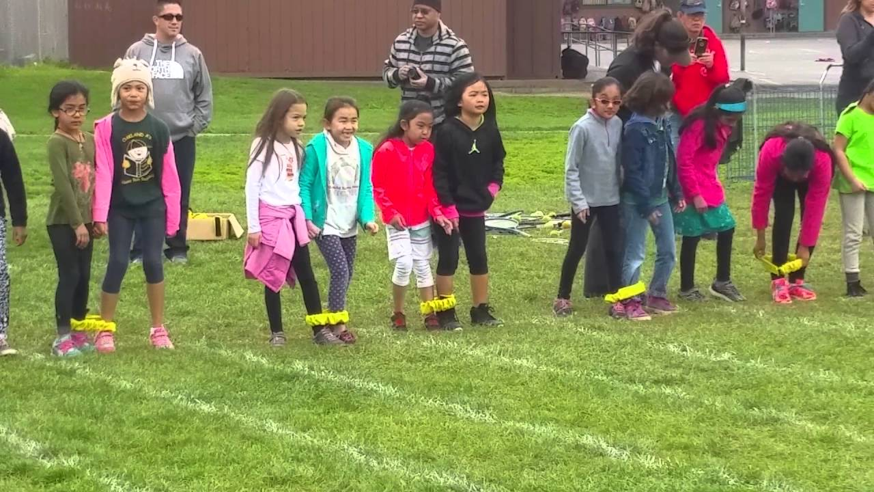

INSTRUCTIONS:
(In this relay race we encourage you to race as a team. Have families/friends get into teams.)

Today you are going to race two by two – and if you do it right – that will be good news.

Two of you will race down and then back.

Then switch out and the next two will run down and back.

Do this until everyone has run at least once. Have fun.

Take a minute to pair up. And wait until I say go.

Bounce House

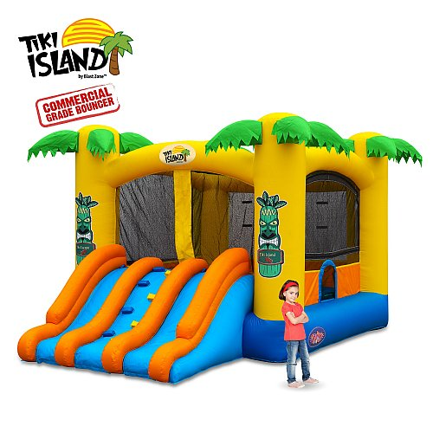

Staff Needed: 4
Sign for Booth: Not Needed (Made)
Activity: Guests can bounce while waiting to start.

What we are asking you to do to prepare:

You just need to monitor this booth.

Kids must take off their shoes before entering.

No flips or rolls – just bouncing.

Please only let a safe number of kids in the bounce house.

Please have similar age/sized kids bouncing together.

